Multivariate Analysis
- Which city has the highest rated restaurant for Chinese cuisines?

Answer:

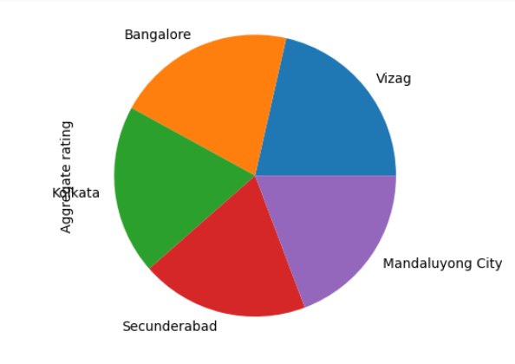

City Rating

Vizag 4.900000
Bangalore 4.700000
Kolkata 4.444444
Secunderabad 4.400000
Mandaluyong City 4.400000

- Pie Chart About

- It shows the Aggregate rating (average ratings) of restaurants in different cities.
- The chart is divided into 5 parts (Vizag, Bangalore, Kolkata, Secunderabad, Mandaluyong City).
- Each part of the circle represents the rating share of that city.
- This chart is comparing restaurant ratings in 5 cities, and we can see that all cities have nearly equal ratings.

- Which restaurant have the highest rating but very low number of votes?
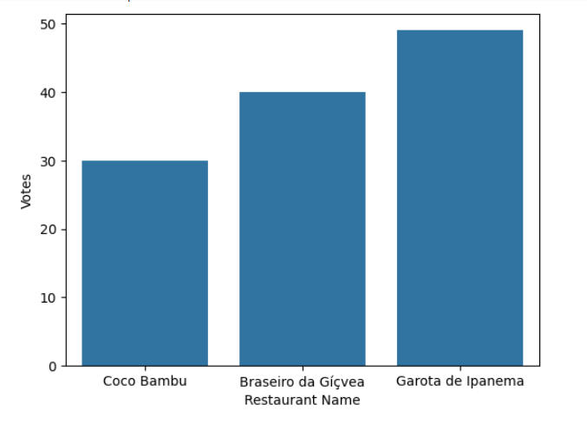

- Bar Chart About

- Coco Bambu got about 30 votes.
- Braseiro da Gávea got about 40 votes.
- Garota de Ipanema got about 50 votes.
- Among these three restaurants, Garota de Ipanema is the most popular (highest votes), and Coco Bambu is the least popular (lowest votes).

- Find the most common average cost for two among restaurants with more than 500 votes.

Answer:

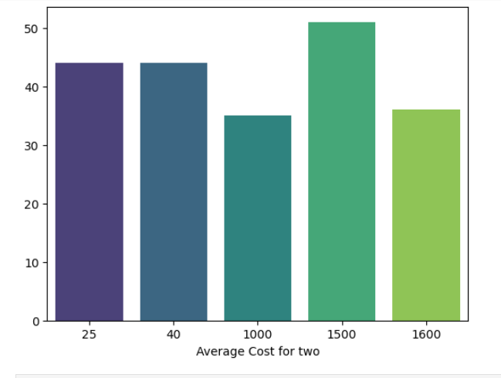

- Bar Chart About

- When the cost is around 25 or 40, restaurants got about 44–45 votes.
- When the cost is around 1000, votes are lower (about 35 votes).
- When the cost is 1500, votes are the highest (about 51 votes).
- When the cost is 1600, votes drop again (about 36 votes).
- People voted the most for restaurants where two people spend about 1500. Restaurants with very high cost (1600) or medium cost (1000) got fewer votes.

- Which cities have costly restaurant with good rating?

Answer:

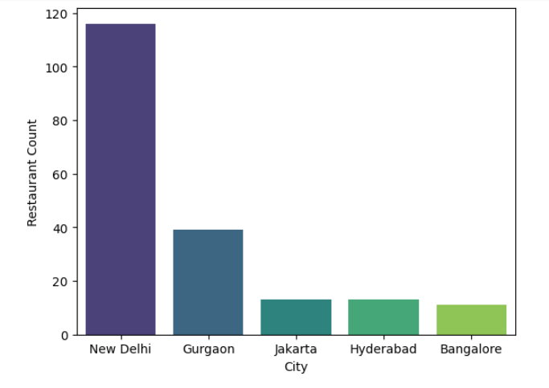

- Bar Plot About

- New Delhi has the most restaurants (around 115).
- Gurgaon comes next with about 40 restaurants.
- Jakarta, Hyderabad, and Bangalore each have around 10–15 restaurants, which is much fewer than New Delhi.
- New Delhi has the highest restaurant count, Gurgaon is far behind, and the other three cities have very few restaurants compared to them.

- What is the relationship between cost, rating, and number of votes?

Answer:

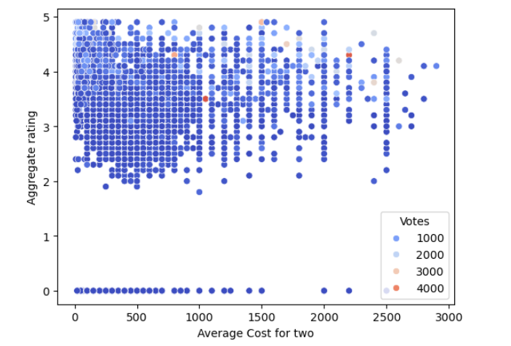

- Scatter plot About

- The x-axis shows the average cost for two people (from 0 to 3000).
- The y-axis shows the rating (from 0 to 5).
- Each dot is a restaurant.
- The color/size of the dots shows the number of votes (how many people rated it).
- Most restaurants cost less than 1000 for two people.
- Many of these restaurants have ratings between 3 and 4.5.
- Few restaurants are very expensive (2000+), but they also get good ratings.

- Which cities have restaurant that offer online delivery and also have high vote?

Answer:

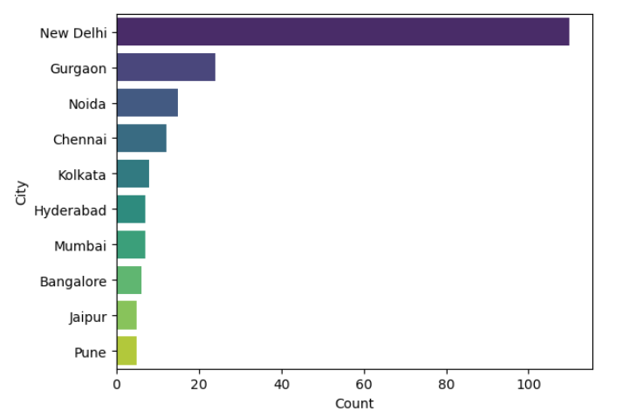

- Bar Plot About

- New Delhi has the highest number of restaurants (above 100).
- Gurgaon is next with around 25 restaurants.
- Noida and Chennai have around 15 restaurants each
- Kolkata, Hyderabad, Mumbai, Bangalore, Jaipur, and Pune have fewer (less than 10–12 restaurants each).

- What type of cuisines are served in cities where the average cost is high but ratings are low?

Answer:

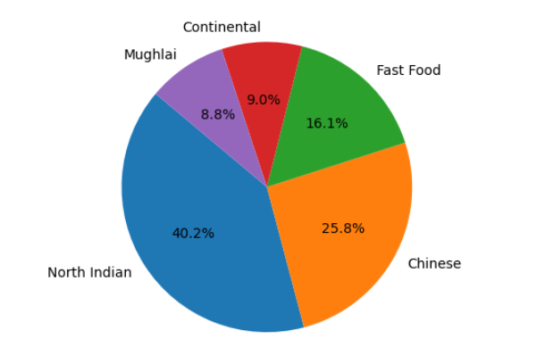

- Pie Chart About
- North Indian food is the most common (40.2%).
- Chinese is the second most common (25.8%).
- Fast Food is next (16.1%).
- Continental (9.0%) and Mughlai (8.8%) are the least common.
- Most restaurants serve North Indian food, then Chinese, and fewer serve Continental or Mughlai food.

- Find the average cost for two at restaurant with rating above 3.5?

Answer:

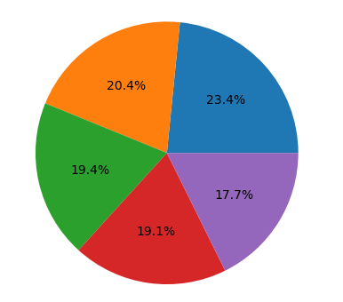

- Pie Chart About

- it represents the distribution of restaurants with rating above 3.5 based on their average cost for two.
- Each slice shows a percentage of restaurants in a particular cost range.

- Find the average cost for two at restaurant with rating above 4?
Answer:

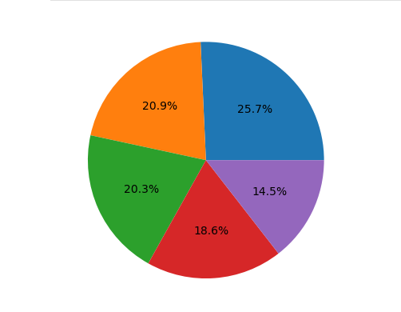
- Pie Chart About
- The pie chart is divided into five colored sections, each showing a percentage.

- Each percentage represents the share of restaurants (with rating above 4) in terms of their average cost for two.

10.Which cities have costly restaurant with good rating?

Answer:

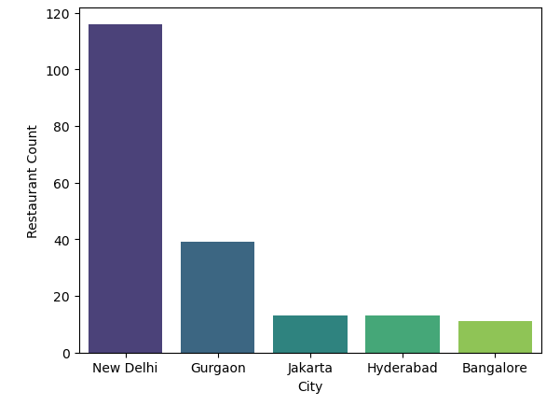

- Bar Plot About

- The graph shows the number of restaurants in different cities.

- New Delhi has the highest number of restaurants (around 117) – much more than all the others.
- Gurgaon comes second with about 40 restaurants.
- Jakarta and Hyderabad have a similar count (around 13 each).
- Bangalore has the lowest here (around 11).
- So the main point: New Delhi has the most restaurants by far, while the other cities have much fewer.

11.What is the relationship between cost, rating, and number of votes?
Answer:

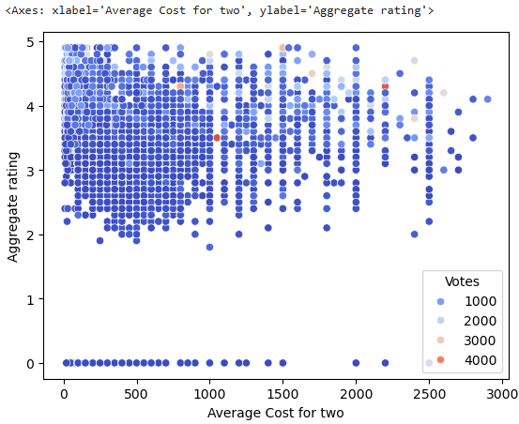

- This chart is a scatter plot showing how average cost for two, aggregate rating, and number of votes are related:

  - X-axis (horizontal) → Average cost for two (how much a meal for two people costs).

  - Y-axis (vertical) → Aggregate rating (restaurant’s average rating, between 0–5).

  - Bubble size & color → Number of votes (how many people rated the restaurant).
- Most restaurants have low to moderate cost (under 1000) and ratings between 3.0 and 4.5.

- High cost does not always mean higher rating. Even restaurants with expensive meals (above 2000) can have average ratings.

- Restaurants with many votes (big light-colored bubbles) are usually clustered between ratings 3.5–4.5, showing that popular restaurants tend to have good ratings.

- Low-rated restaurants (below 2.0) exist at all cost levels, meaning poor service/food can happen regardless of price.

- Zero ratings (flat at bottom) show some places are not rated even if their costs vary.

12. Which cities have restaurant that offer online delivery and also have high vote?
Answer:

- City

- New Delhi 5473
- Gurgaon 1118
- Noida 1080
- Faridabad 251
- Ghaziabad 25
- Panchkula 1
- Mc Millan 1
- Mayfield 1
- Macedon 1
- Vineland Station 1

- this table is showing cities where restaurants offer online delivery and also received high votes.

- New Delhi has the highest number with 5473 restaurants that provide online delivery and also have a large number of votes.

- Gurgaon (1118), Noida (1080), and Faridabad (251) follow as the next biggest hubs.

- Some cities like Panchkula, Mc Millan, Mayfield, Macedon, and Vineland Station have only 1 restaurant each in this category.

13. Which restaurant with table booking and high cost for two have the most vote?
Answer:

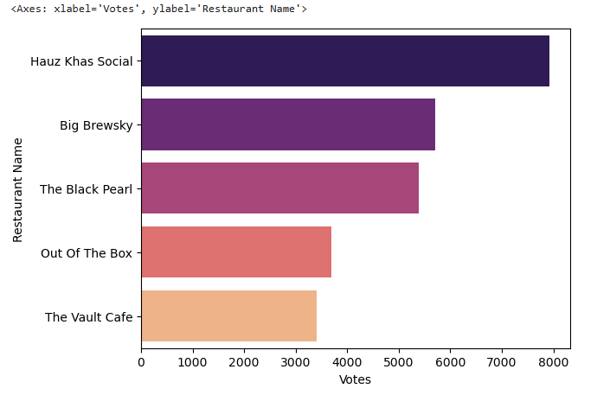
- It shows restaurants that have table booking, high cost for two, and their votes.

- Hauz Khas Social → has the highest number of votes (8000).

- The restaurant with table booking, high cost for two, and the most votes is Hauz Khas Social.

14 Where are the restaurants that offer both table booking and delivery?

Answer:

- Only New Delhi has restaurants that offer both table booking and online delivery, with a count of 1 restaurant.

- That means in the dataset, there is just one restaurant in New Delhi that provides both services together.

15. Where are the restaurant that offer online delivery and have high vote?
Answer:

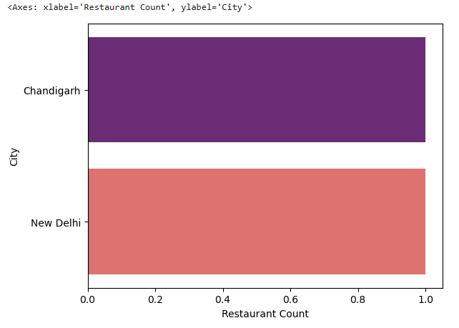

- The restaurants that offer online delivery and also have high votes are located in:

    - New Delhi
    - Chandigarh

- Each of these cities has 1 restaurant that fits the condition (online delivery + high votes).

16.Which cities have restaurant with table booking, high rating and costly cuisines?
Answer:

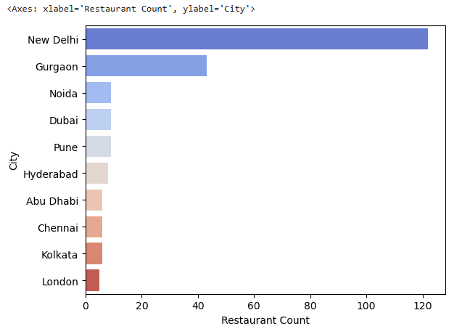

- The cities that have restaurants with table booking, high rating, and costly cuisines are:

  - New Delhi – the highest count (over 120 restaurants).
  - Gurgaon – second highest (around 40+ restaurants).
  - Noida – smaller count.
  - Dubai
  - Pune
  - Hyderabad
  - Abu Dhabi
  - Chennai
  - Kolkata
  - London – lowest count.

- New Delhi leads by a very big margin compared to all other cities.
17.Which restaurant that serve excellent cuisines and get most vote?
Answer:

Restaurant Name | Cuisines | Aggregate Rating | Votes | City
Toit | Italian, American, Pizza | 4.8 | 10,934 | Bangalore
Truffles | American, Burger, Cafe | 4.7 | 9,667 | Bangalore
AB's - Absolute Barbecues | European, Mediterranean, North Indian | 4.6 | 6,907 | Bangalore
Barbeque Nation | North Indian, Chinese | 4.9 | 5,966 | Kolkata
Big Brewsky | Finger Food, North Indian, Italian, Continental | 4.5 | 5,705 | Bangalore
- Toit (Bangalore) has the highest votes, while Barbeque Nation (Kolkata) has the highest rating (4.9).

18.What type of cuisines are served in cities where the average cost is high but ratings are low?
Answer:

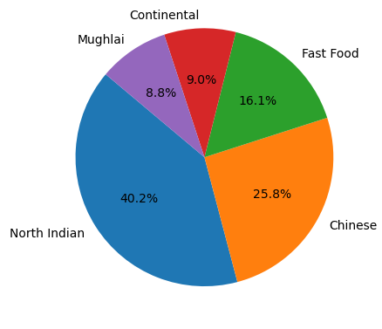
- Pie Chart About

- pie chart, we can see the distribution of cuisines in cities where the average cost is high but ratings are low:

- North Indian dominates even in cities where food is costly but ratings are poor.
- Chinese and Fast Food are also significant contributors in this category.
- Continental and Mughlai have a smaller but still notable presence.

19.Find out which cities have restaurants that are Expensive, Offer online delivery, and Have good ratings?
Answer:

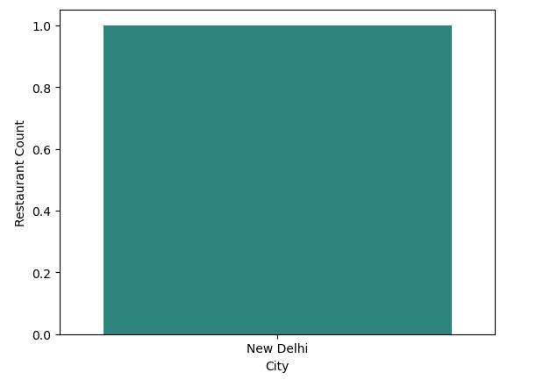

- Bar Chart About :

- New Delhi is the city that has restaurants which are:
- Expensive (High cost for two)
      - Offer Online Delivery
      - Have Good Ratings

- Only New Delhi meets all three conditions in your dataset.

20.Which types of cuisines are commonly offered in cities that have many highly rated restaurants?
Answer:

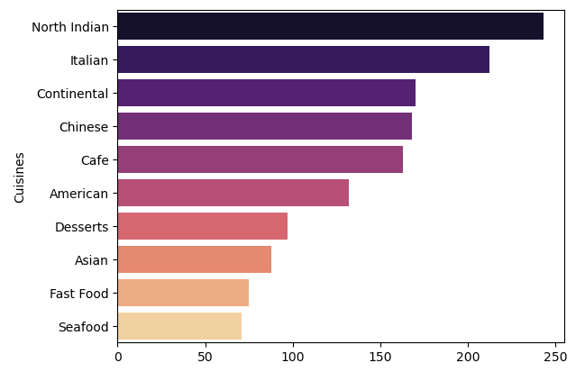

- Bar Chart About :

- From the bar chart, we can see the types of cuisines most commonly offered in cities with many highly rated restaurants:

- North Indian – most common, offered in nearly 240 restaurants.
- Italian – second most popular, with over 210 restaurants.
- Continental – widely served, around 170 restaurants.
- Chinese – also around 170 restaurants.
- Cafe – slightly lower but still significant (~165 restaurants).
- American – ~135 restaurants.
- Desserts – just under 100 restaurants.
- Asian – ~90 restaurants.
- Fast Food – ~75 restaurants.
- Seafood – least common among the top cuisines (~70 restaurants).

- Highly rated restaurants tend to serve North Indian, Italian, Continental, Chinese, and Cafe cuisines most often.
22. Find restaurants where The cost for two is very high, The rating is low, And the number of votes is few.
Answer:

 | Restaurant  Name | City | Cuisines | Rating | Votes | Avg. Cost for Two
 | Malt n Brew | Noida | North Indian, Continental, Chinese | 0.0 | 0 | ₹2000
 | Airborne | Noida | North Indian, Chinese, Continental, Mughlai | 0.0 | 0 | ₹2000

- Both restaurants are located in Noida
- Both serve multi-cuisine menus (North Indian + Continental + Chinese; one includes Mughlai)

- Both are expensive (₹2000 for two)
- Both have 0.0 rating (lowest)

- Both have 0 votes, suggesting very few/no customers have rated them

23.Find restaurants that have a good rating but do not offer table booking.?

Answer:

 | Restaurant Name |  | City |  | Cuisines |  |  | Rating |  | Table Booking
1 | Ooma |  | Mandaluyong City |  | Japanese, Sushi |  |  | 4.9 |  | No
2 | Mr. Dunderbak's Biergarten and Marketplatz |  | Tampa Bay |  | European, German |  |  | 4.9 |  | No
3 | Barbeque Nation |  | Kolkata |  | North Indian, Chinese |  |  | 4.9 |  | No
4 | Zolocrust - Hotel Clarks Amer |  | Jaipur |  | Italian, Bakery, Continental |  |  | 4.9 |  | No
5 | AB's - Absolute Barbecues |  | Hyderabad |  | European, Mediterranean, North Indian |  |  | 4.9 |  | No
- All 5 restaurants listed have an excellent rating (4.9) but do not provide table booking.

24.What type of restaurant offer table booking, cost more, and serve popular cuisines?
Answer:

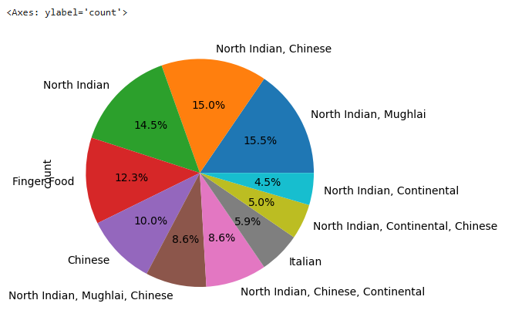

Answer:

- Restaurants that offer table booking, cost more, and serve popular cuisines are most often those serving:

- From the data and chart:

- The popular cuisines (largest shares in the pie) are:

- North Indian, Mughlai (15.5%)
- North Indian, Chinese (15.0%)
- North Indian (14.5%)
- Finger Food (12.3%)
- Chinese (10.0%)
25.Which cuisines are most commonly served in top-rated restaurants that also offer online delivery?
Answer:

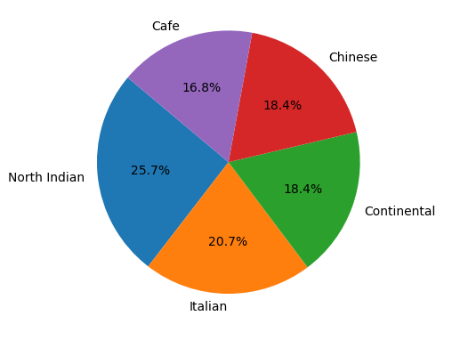

- Represents cuisines served in top-rated restaurants that also offer online delivery:

- Distribution:
- North Indian – 25.7% (highest)
- Italian – 20.7%
- Chinese – 18.4%
- Continental – 18.4%
- Café -16.8%
- The cuisines most commonly served in top-rated restaurants with online delivery are:

- North Indian (most dominant)
- Italian
- Chinese and Continental (equally popular)

26.What are the cuisine types in top-voted restaurants that offer both online delivery and table booking?
Answer:
Cuisine | Count
North Indian | 50
Italian | 40
Chinese | 34
Continental | 28
American | 19
- The most common cuisines in top-voted restaurants with both online delivery and table booking are:

  - North Indian (most dominant)
  - Italian
  - Chinese
  - Continental
  - American

27.Which cuisines are served at restaurants that Allow table booking Have high cost for two?
Answer:

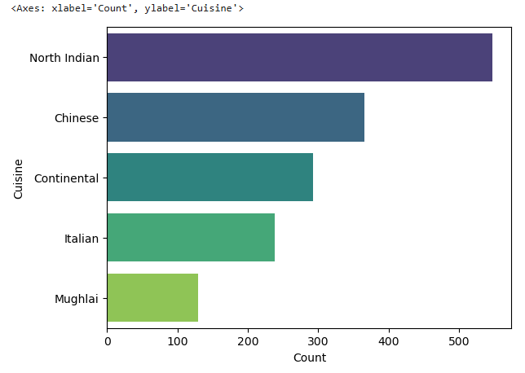

- we can see the cuisines served at restaurants that allow table booking and have a high cost for two.

- Cuisines Offered:

    - North Indian – Most dominant cuisine
    - Chinese – Also widely offered
    - Continental – Frequently available
    - Italian – Popular in high-cost restaurants
    - Mughlai – Present but less common compared to others

- High-cost restaurants with table booking most commonly serve North Indian, Chinese, Continental, Italian, and Mughlai cuisines, with North Indian being the most frequent.

28.What type of cuisines are served in highly rated, excellent restaurants with table booking?
Answer:

Cuisine |  | Count
Indian |  | 4
North Indian |  | 3
Chinese, Dim Sum |  | 2
Filipino |  | 2
Indian, North Indian |  | 2

- Indian (4) is the most common cuisine among excellent, highly rated restaurants with table booking.

- North Indian (3) is also very popular.

- Chinese, Dim Sum (2) and Filipino (2) cuisines appear less frequently but still significant.

- Some restaurants serve Indian + North Indian (2) as a combined cuisine.

29.Find the cities that have restaurants Price range is high, Low customer votes?

Answer:

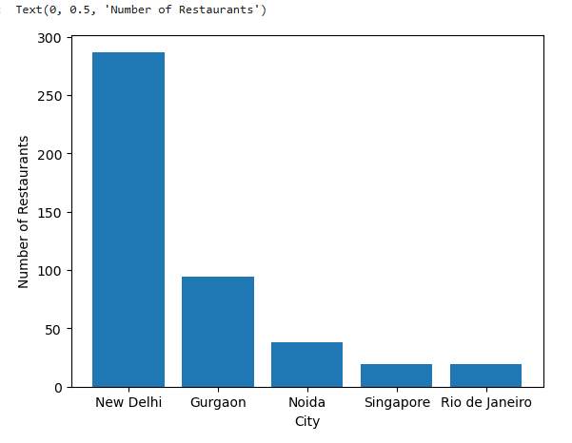

- Bar Chart About :

- New Delhi – The highest number of restaurants fall into this category, showing many expensive restaurants with fewer customer votes.

- Gurgaon – Also has a significant number of high-price, low-vote restaurants.

- Noida, Singapore, and Rio de Janeiro – Appear as smaller contributors but still present in this category.

- So, the main cities are: New Delhi, Gurgaon, Noida, Singapore, and Rio de Janeiro.

30. Which cities have restaurants that are expensive, highly rated, and do not offer online delivery?
Answer:
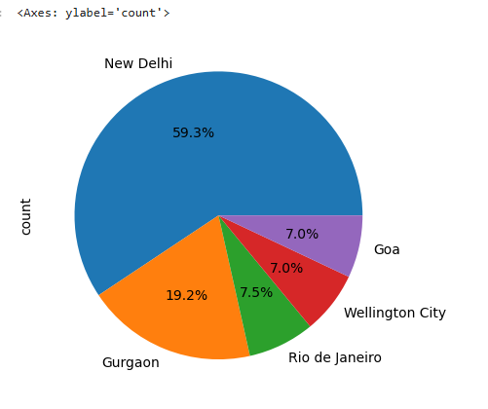
- Pie Chart About:

- cities that have restaurants which are expensive, highly rated, but do not offer online delivery are:

- New Delhi – 59.3% (the majority)
- Gurgaon – 19.2%
- Rio de Janeiro – 7.5%
- Wellington City – 7.0%
- Goa – 7.0%

- So, New Delhi and Gurgaon dominate, but a few international and coastal cities (Rio de Janeiro, Wellington City, Goa) also have such restaurants.

31. List the restaurants that have poor ratings, but provide both table booking and delivery.
Answer:

Restaurant Name | City | Cuisines
Pind Balluchi | Ghaziabad | North Indian, Mughlai
Chutneez Restaurant Lounge & Bar | New Delhi | North Indian, Chinese, Mughlai
Chawla’s_ | New Delhi | North Indian, Mughlai
Basil Tree | New Delhi | North Indian, Italian, Chinese
Pind Balluchi | New Delhi | North Indian, Mughlai
Moti Mahal Delux Tandoori Trail | New Delhi | North Indian, Mughlai
Yo! China | New Delhi | Chinese
Kamboj’s | Noida | North Indian, Mughlai, Chinese
Chawla’s_ | Noida | North Indian, Mughlai, Chinese
The Caspian | Noida | North Indian, Chinese
Moti Mahal Delux Tandoori Trail | Noida | North Indian, Mughlai
- Common cuisines among these low-rated but service-rich restaurants are North Indian, Mughlai, and Chinese.

32.Which cuisines are usually served by restaurants that have a dark green rating color?

Answer:

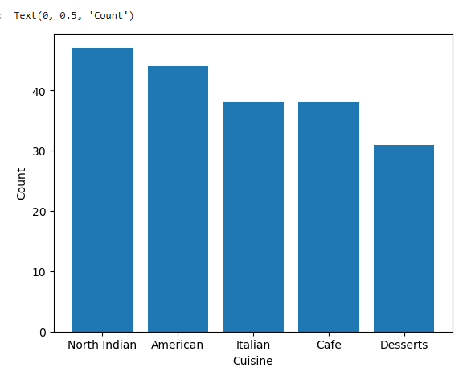

- Bar Chart About:

- The cuisines that are usually served by restaurants with a dark green rating color are:

- North Indian (highest count)
- American
- Italian
- Café
- Desserts (lowest among them)

- This means that North Indian and American cuisines dominate in restaurants with dark green ratings, while Desserts are less frequent.

33. What is the most common price range in restaurants that offer delivery and have high rating?

Answer:
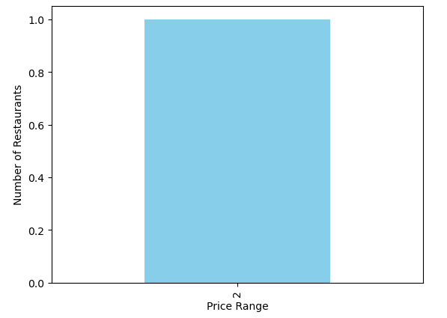
- Bar Chart About:

- most common price range in restaurants that offer delivery and have high ratings is:

- Price Range = 2

- This means that moderately priced restaurants (range 2) dominate among those providing delivery and maintaining high ratings.

34.Where are restaurant that high rating but low cost cuisines and have few vote?
Answer:

City | Restaurant Count
New Delhi | 41
Gurgaon | 14
Noida | 5
Guwahati | 4
Edinburgh | 3
Bhubaneshwar | 3
Birmingham | 2
Dehradun | 2
Agra | 2
Surat | 1

- The restaurants that are highly rated, low-cost, but have few votes are mainly concentrated in these cities:

- The majority are in New Delhi, followed by Gurgaon.

35.Which restaurant that perform high rating, high vote and dark green?
Answer:

Restaurant Name | City
Izakaya Kikufuji | Makati City
Spiral – Sofitel Philippine Plaza Manila | Pasay City
Locavore | Pasig City
Silantro Fil-Mex | Pasig City
NIU by Vikings | Taguig City

- the list of restaurants that have high rating, high votes, and a dark green rating color:

36. Which cities have restaurants that are not offering table booking and not offering delivery?
Answer:
City | Restaurant Count
New Delhi | 4743
Noida | 963
Gurgaon | 902
Faridabad | 236
Ghaziabad | 22
Lucknow | 2 1
Guwahati | 21
Ahmedabad | 21
Bhubaneshwar | 21
Amritsar | 21
- Here are the cities with restaurants that do not offer table booking and do not offer delivery:

- New Delhi dominates with the highest number of such restaurants.

37.Which cuisines are served by restaurants with dark green rating color, online delivery, and table booking?
Answer:
- Here are the cities with restaurants that do not offer table booking and do not offer delivery:

City | Restaurant Count
New Delhi | 4743
Noida | 963
Gurgaon | 902
Faridabad | 236
Ghaziabad | 22
Lucknow | 21
Guwahati | 21
Ahmedabad | 21
Bhubaneshwar | 21
Amritsar | 21

- New Delhi dominates with the highest number of such restaurants.
38. Where can find restaurant that allow high cost, allow table booking and have high rating?

Answer:

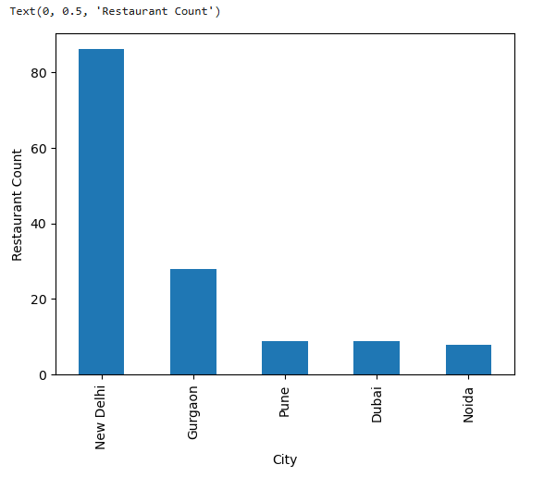

- Bar Chart About:
- X-axis (City): Represents the cities where restaurants are located.

- Y-axis (Restaurant Count): Shows how many restaurants meet the condition — high cost, table booking allowed, and high rating.

- New Delhi dominates heavily with around 87 restaurants, meaning most high-cost, highly rated restaurants with table booking are concentrated there.

- Gurgaon comes next with about 28 restaurants, a significant but much smaller share compared to New Delhi.

- Pune, Dubai, and Noida each have fewer (between 8–9 restaurants), showing that while such restaurants exist, they’re relatively rare compared to Delhi/Gurgaon.

39.In which cities, which restaurants are not offering table booking and delivery?

Answer:
- Here’s the list of cities and their restaurants that are not offering table booking and not offering delivery

City | Restaurant Name
Mandaluyong City | Ooma
Mandaluyong City | Din Tai Fung
Pasig City | Silantro Fil-Mex
Quezon City | Silantro Fil-Mex
San Juan City | Sodam Korean Restaurant

- This shows that these 5 restaurants across Mandaluyong, Pasig, Quezon, and San Juan fall into that category.

40.Find the restaurant that has High Rating, Rare Cuisine and Maximum Votes?

Answer:

- The restaurant that meets the conditions (High Rating, Rare Cuisine, and Maximum Votes) is:

- Restaurant Name | Cuisines | Aggregate Rate | Votes | City
Café Lota | North Indian, South Indian, Bihari | 4.5 | 2213 | New Delhi

- Café Lota (New Delhi) stands out because it has a high rating (4.5), serves a rare cuisine combination (North Indian, South Indian, Bihari), and also has the maximum votes (2213) among such restaurants.

41.Which cuisines have high rating and offer table booking?

Answer:

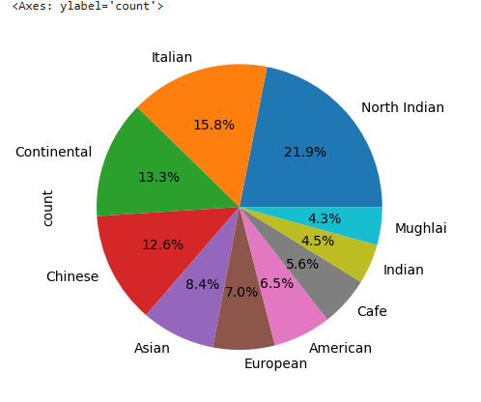

- Pie Chart About:

- The chart represents the distribution of cuisines among restaurants that have high ratings and allow table booking.

- Each slice corresponds to a cuisine, and the percentage indicates its share.

- North Indian cuisine clearly dominates, meaning if a restaurant is highly rated and accepts bookings, it’s most likely to serve North Indian food.

- Italian and Continental also play a strong role in the fine-dining or bookable category.

- Smaller slices (Café, Indian, Mughlai) show cuisines that are present but less frequent in high-rated, table-booking restaurants.
- The pie chart shows that North Indian, Italian, Continental, and Chinese cuisines are the most common among restaurants with high ratings and table booking options.

42.Which cuisines are served by restaurants with high ratings and no online delivery?

Answer:

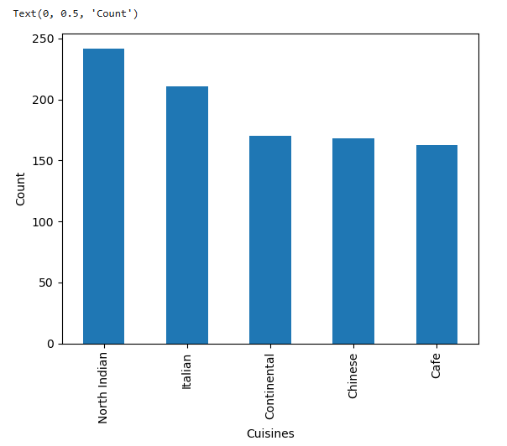
- Bar Chart About:

- The graph represents the cuisines offered by restaurants that have high ratings but do NOT provide online delivery.

- North Indian cuisine leads strongly — meaning that most high-rated dine-in restaurants (without delivery) serve North Indian food.

- Italian, Continental, and Chinese cuisines also appear frequently in high-rated no-delivery restaurants — suggesting these are often fine-dining or dine-in oriented.

- Café-style restaurants also show up, but less than the big four cuisines.

- Conclusion:

- Restaurants with high ratings and no delivery most commonly serve North Indian, Italian, Continental, Chinese, and Café cuisines.

43.Which cuisines have high ratings and what is their average cost for two?
Answer:
Cuisine | Average Cost for Two
Western | 388,333.33
Indonesian | 313,000.00
Sunda | 200,000.00
Sushi | 100,322.00
Coffee and Tea | 82,512.50
- Western cuisine → Highest average cost Often associated with fine dining and imported ingredients.

- Indonesian cuisine → Also high suggesting premium Indonesian restaurants

.
- Sunda cuisine → Moderate cost possibly more traditional/local dining

- Sushi → More affordable though usually premium elsewhere, here it appears mid-range.

- Coffee and Tea → Lowest cost aligning with casual cafés and beverage-focused outlets.

- Conclusion

  - Western & Indonesian cuisines are the most expensive among high-rated restaurants.

  - Sunda & Sushi fall into the moderate price range.

  - Coffee and Tea is the most affordable high-rated option.

44. In which cities, which restaurants have good ratings?

Answer:

City | Restaurant Name | Aggregate Rating
Augusta | Rae’s Coastal Café | 4.9
Auckland | Milse | 4.9
London | Bao | 4.9
Guwahati | Barbeque Nation | 4.9
Hyderabad | AB’s – Absolute Barbecues | 4.9
Hyderabad | AB’s – Absolute Barbecues | 4.9
London | Duck & Waffle | 4.9
London | Flat Iron | 4.9
Cedar Rapids/Iowa City | Shorts Burger and Shine | 4.9
Jaipur | Zolocrust – Hotel Clarks Amer | 4.9
- Table Shows:

- London → Has multiple top-rated restaurants (Bao, Duck & Waffle, Flat Iron).

- Hyderabad → AB’s – Absolute Barbecues appears twice (possibly multiple outlets).

- Other cities with single standout high-rated restaurants → Augusta, Auckland, Guwahati, Cedar Rapids/Iowa City, Jaipur.

45.Which restaurants have low cost for two and the most votes?
Answer:
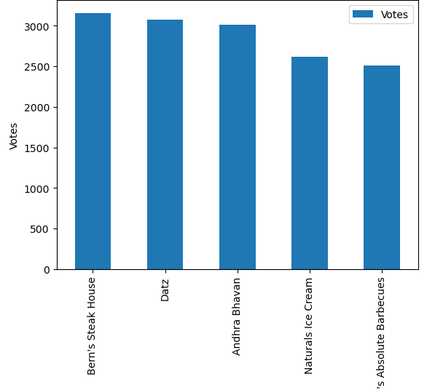

- Bar Chart About:

- The bar chart you shared shows the restaurants with the highest number of votes.

- From the chart, the restaurants with the most votes are:
  - Bern’s Steak House
  - Datz
  - Andhra Bhavan
  - Naturals Ice Cream
  - AB’s Absolute Barbecues

- Andhra Bhavan and Naturals Ice Cream are known for being low cost for two while still attracting a large number of votes.

- The others (Bern’s Steak House, Datz, AB’s Absolute Barbecues) are popular but tend to have moderate to higher costs.

- So, Andhra Bhavan and Naturals Ice Cream → Low cost for two & high votes

46.Which restaurants have low rating but table booking is available?

Answer:
Restaurant Name | Aggregate Rating | City
Roasted – Roseate | 0.0 | New Delhi
F Marquee | 0.0 | New Delhi
Hang Out | 0.0 | New Delhi
Pind Balluchi | 0.0 | New Delhi
Hotel Delhi 43 | 0.0 | New Delhi
Boozer’s | 0.0 | Gurgaon
Taaj Kitchen | 0.0 | New Delhi
Lord’s – The Sports Lounge | 0.0 | New Delhi
London Eye – The Open Lounge | 0.0 | New Delhi
Curzon – The Royal Bar | 0.0 | New Delhi
- Most of these are concentrated in New Delhi, with only one in Gurgaon (Boozer’s).

47.Who are the restaurant that serve excellent cuisines and get most vote?
Answer:

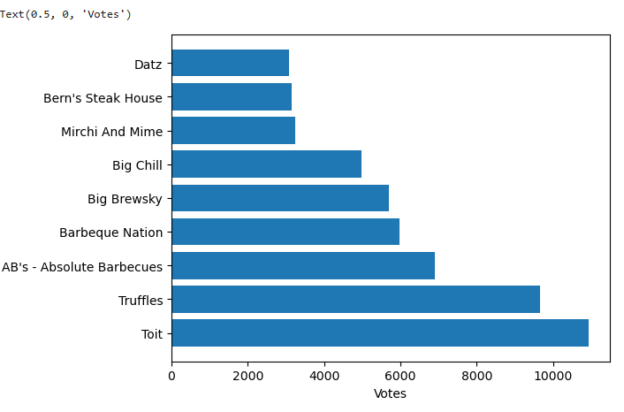

- Bar Chart About:

- X-axis (horizontal): Number of Votes (popularity)
- Y-axis (vertical): Restaurant Names

- Most Voted Restaurants:
- Toit has the highest votes making it the most popular restaurant.
- Truffles comes second.
- Both are far ahead compared to the others.

- Mid-Range Votes:
- AB’s – Absolute Barbecues, Barbeque Nation, and Big Brewsky fall in the middle).
- These are still very popular but not as dominant as Toit and Truffles.

- Lower Votes:
- Big Chill, Mirchi And Mime, Bern’s Steak House, and Datz have comparatively fewer votes.
- They are still liked but clearly less popular.

48.Which cuisines have high cost, low rating, and high vote?

Answer:

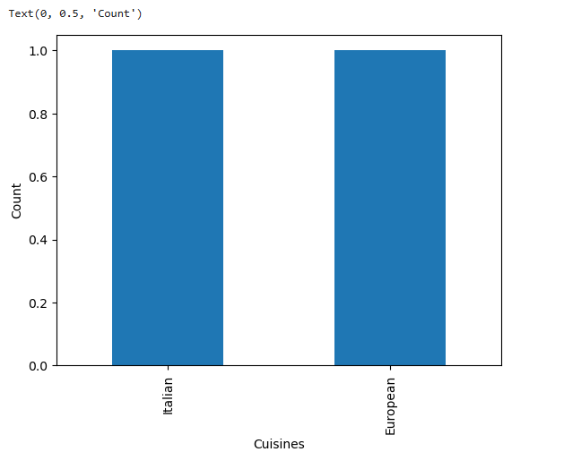

- Bar Chart About:

- X-axis: Cuisines (Italian, European)
- Y-axis: Count (how many cuisines fall under the criteria).

- Both Italian and European cuisines meet the conditions of having:

- High cost for two
- Low ratings
- High votes

- Customers are still voting (engaging) for Italian and European restaurants, but they:

- Charge high prices
- Receive low satisfaction ratings
- Yet, they attract a lot of customer attention (maybe because they are trendy, popular, or have brand recognition).

- So, the cuisines with high cost, low rating, and high votes are:
Italian & European

49. Which cuisines are offered by costly restaurants that provide the table booking option?

Answer:

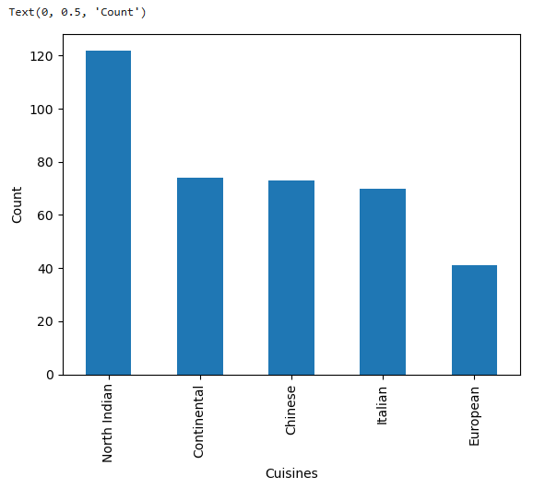

- Bar Chart About:

- X-axis → Cuisines

- Y-axis → Count (number of costly restaurants that also provide table booking option).

- North Indian cuisine dominates → with the highest number of costly restaurants offering table booking.

- Followed by Continental, Chinese, and Italian cuisines → these also have many costly restaurants with table booking.

- European cuisine → has the least number of costly restaurants with booking, but still present.

- Conclusion:

- The cuisines offered by costly restaurants that provide table booking are:

- North Indian, Continental, Chinese, Italian, and European

50. Which cities and which restaurants allow table booking and have a high price range?

Answer:

City | Restaurant Name | Price Range
Mandaluyong City | Heat – Edsa Shangri-La | 4
Mandaluyong City | Sambo Kojin | 4
Pasay City | Buffet 101 | 4
Pasay City | Vikings | 4
Pasay City | Spiral – Sofitel Philippine Plaza Manila | 4

